EXAMPLE

8

9

7

2

4

5

8

6

YOUR NAME: __________________________________
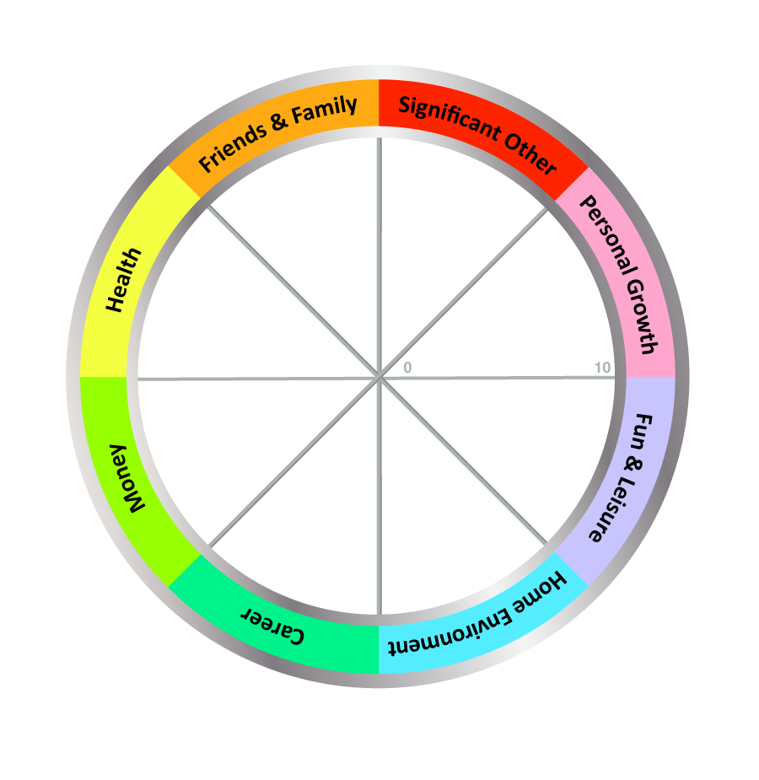

TODAY'S DATE: ____________________

COMPLETE THE WHEEL:

1. Review the Eight Wheel Categories - think briefly, what a satisfying life might look like for you in each area

2. Next, draw a line across each segment that represents your satisfaction score for each area.

- Imagine the centre of the wheel is 0 and the outer edge is 10
- Choose a value between 1 (very dissatisfied) and 10 (fully satisfied)
- Now draw a line and write the score alongside (see example above)

IMPORTANT: Use the FIRST number (score) that pops into your head, not the number you think it should be!

The Wheel of Life Exercise – Instructions

Detailed Instructions:
- Review the eight categories on the Wheel of Life. The categories should, together, create a view of how balanced your life seems at present. If necessary, split category segments and add in something that is missing, or re-label an area to make it more meaningful for you. You might want to make it more specific. Examples of changes are:
  - Family and Friends: Split "Family and Friends" into separate categories.
  - Significant Other: Changing the category name to "Dating", "Relationship" or "Life Partner".
  - Career: Changing the category name to "Motherhood", "Work", "Business" or "Volunteering".
  - Finances: Changing the category name to "Money", "Financial Security" or "Financial Wellbeing".
  - Health: The category name could be split or changed to "Emotional", "Physical", "Fitness", "Spiritual" or "Wellbeing".
  - Home Environment: The category could split or change to "Work Environment" for career or business clients.
  - Fun & Leisure: The category name could change to "Recreation"
  - Personal Growth: The category name could change to "Learning", "Self-Development" or "Spiritual"
  - Other categories to add could include "Security", "Service", "Leadership", "Achievement" or "Community".
- Think about what success or satisfaction would feel like for each area.
- Rank your level of satisfaction within each area of your life by drawing a line across each segment. Place a value between 1 (very dissatisfied) and 10 (fully satisfied) for each area to show how satisfied you are currently with each category within your life.
- The new perimeter of the circle represents your Wheel of Life. Ask yourself about that line- is it high in some places and low in others?
- Now, looking at the wheel, here are some great questions to ask yourself:
  - Are there any surprises for you?
  - How do you feel about your life as you look at your Wheel?
  - How do you currently spend time in these areas? How would you like to spend time in these areas?
  - What would make that a score of 10?
  - What would a score of 10 look like?
  - Which of these categories would you most like to improve?
  - How could you make space for these changes in your life?
  - What help and support might you need from others to make changes and be more satisfied with your life?
  - What change should you make first? And what change do you want to make first?
10.What one action could you take right now that would begin to bring everything into balance?

- Taking action - the final step.
To wrap-up the exercise, ask yourself to identify one action for each area, and then pick 1-3 of those actions to get started. Choose the three areas you most want to work on and identify an action for each. TIP: If you are often extremely busy or stressed, ask yourself, "What is the smallest step you could take to get started?"

Notes:
- Balance and success is personal and unique and different for each individual - what may be satisfying or balanced for some may be stressful or boring for others.

- This exercise raises your current happiness. If you have a low score, ask yourself what changes can be made to increase happiness in that area. Sometimes nothing can be done, for example after the loss of a loved one. In that case think of ways to cope better, gain support or find a sense of peace or acceptance around what can’t be changed. Use this exercise to plan a life that is more satisfying and closer to your values and what, for you, feels more balanced. It also helps clarify priorities for goal-setting.

- Balance must be assessed over time. A regular check-in (eg. with this exercise) can highlight useful patterns and helps you see where you have been doing well and see also where new changes are needed. You can do this with a friend. You can also do this with me, Jason Demant (email me at Jason@jasondemant.com). We can arrange a 30 minute phone or skype conversation to look at your wheel, think about barriers to growth and consider how to manage or create positive change. Since the call can be online, your location can be anywhere in the world, whilst I’m in sunny London, UK!

- Another option is always for you to ask someone who knows you to complete the scores for you (sometimes it's helpful to see an outside perception of your life 'balance', though be prepared to argue too, sometimes). Important: This must be someone you fully trust and whose opinion you value - remember that others may have hidden agendas.

